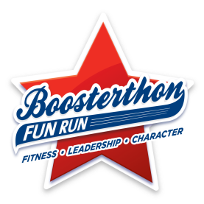
YOLO… Be Drug Free!
Boosterthon Theme: Mindspark Mystery Lab
October 29th – November 2nd
Sponsored by Student Council

Show your pledge to be a good citizen of PHES and to be drug free by participating in Red Ribbon Week Days!
~Remember to check out-of-Uniform guidelines in your student handbook~

Boosterthon Lesson: Growth Mindset
I can be anything with hard work and practice!
Monday, October 29th – Future Career Day!
Dress up like what you want to be when you grow up!

Be Drug Free:
Turn your back on drugs!
Tuesday, October 30th- Backwards Day!
Wear your clothes backwards and/or inside out!

Boosterthon Lesson: Teamwork
Working with others as a team!
Wednesday, October 31st- Sports Day!
Wear something that represents your favorite sport!

Be Drug Free:
Your future is too BRIGHT for drugs!
Thursday, November 1st- Neon Day!
Wear all neon colors!

Boosterthon Fun Run Day K-5
Be Drug Free:
Rally in Red Against Drugs and Bullying!
Friday, November 2nd – Red Day
Wear all red with school appropriate bottoms and athletic shoes!

